**List :**

List is used to store multiple items and they may have different datatypes in a single variable,it is created by placing inside the square brackets separated by commas.

A list can also have another list as an item is called nested list.

List items are ordered, changeable and allow duplicate values. List items are indexed ,the first item has index[0],the second item has index[1] and so on.

Append,copy,count,extend,index,insert,pop,clear,remove,reverse,sort,these are the methods of list.

**Syntax:**

A=[]

**Example:**

A=[‘great’,’minds’,1,2]

**OUTPUT:**

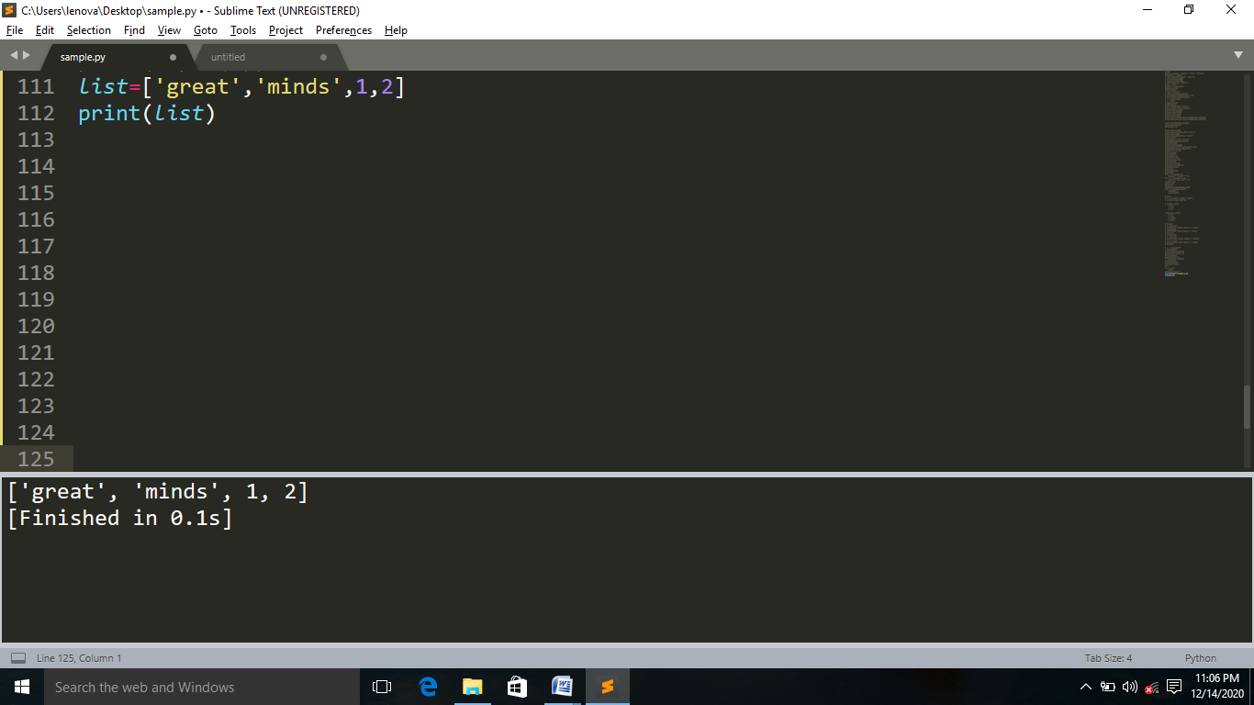

To get index use the syntax: **list.index()**

Example:

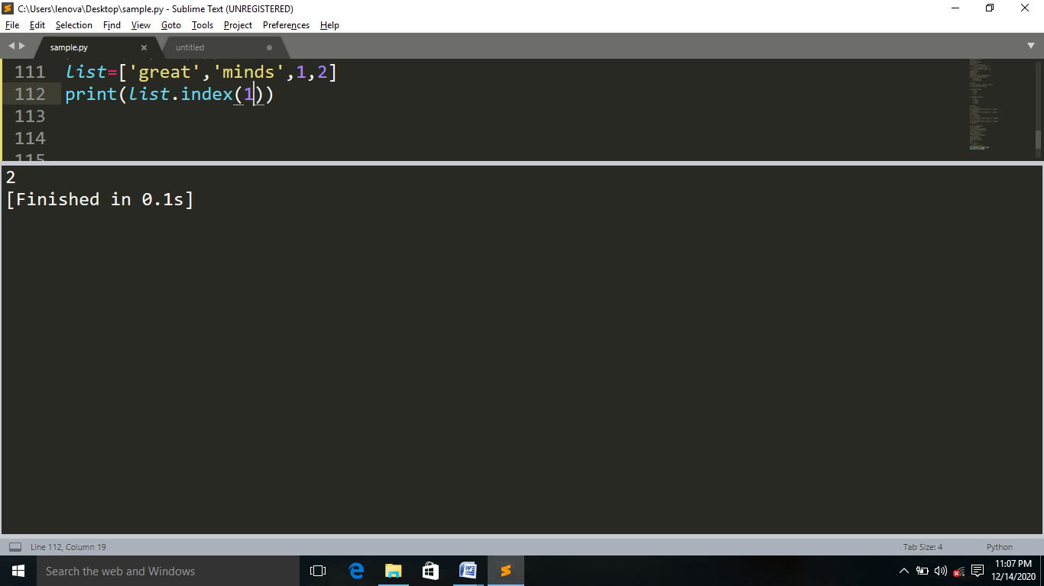

**APPEND**:

To add an item to the end of the list,use the append() method.

**Syntax**

list.append() 🡺take only one argument.

**Example:**

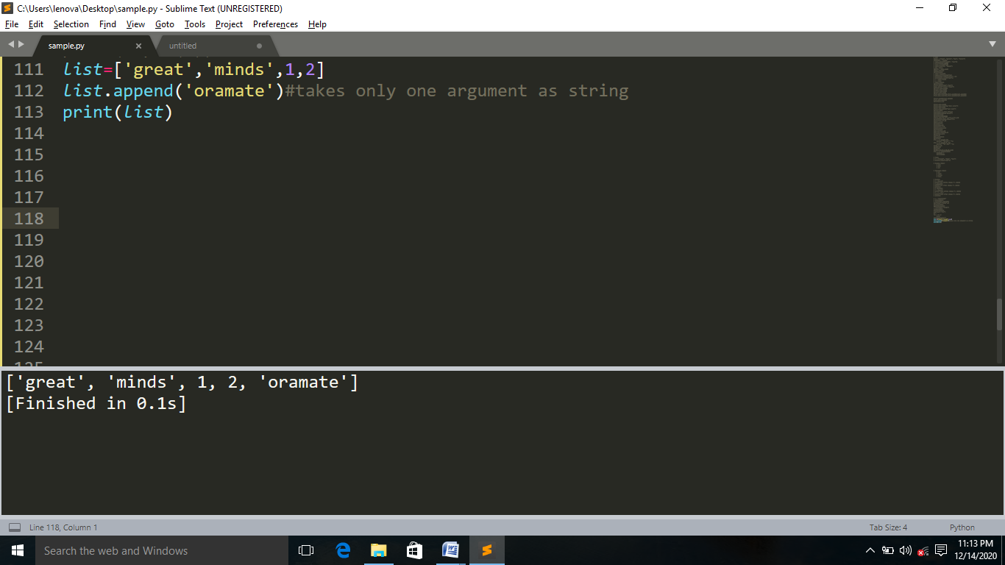

**EXTEND:**

To append element from another list to the current list,use the extend() method.

**Syntax:**

list.extend()🡺non iterable objects does not accept.

**EXAMPLE:**

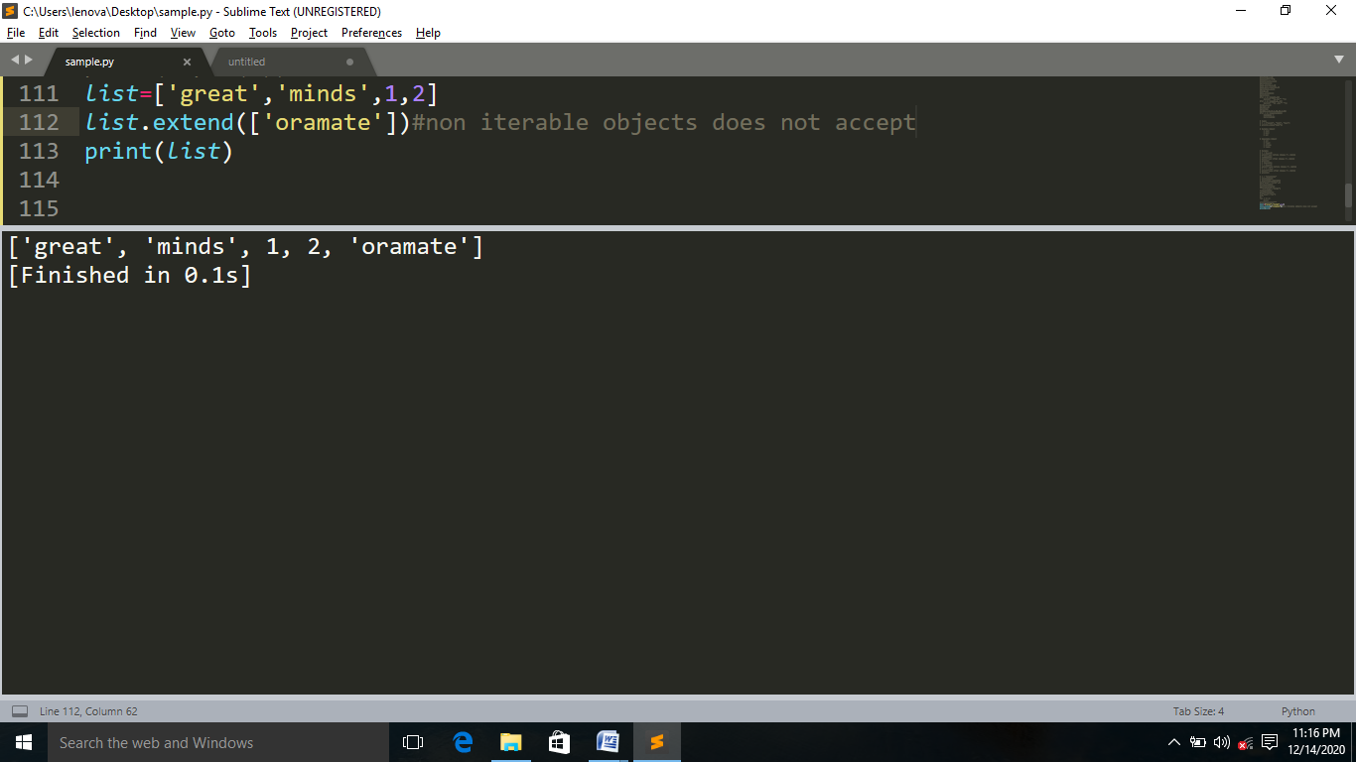

**INSERT:**

To insert a new list item,without replacing any of the existing values,use the insert() method.

**Syntax:**

list.insert(position,”value”)🡺exactly two arguments.

**EXAMPLE:**

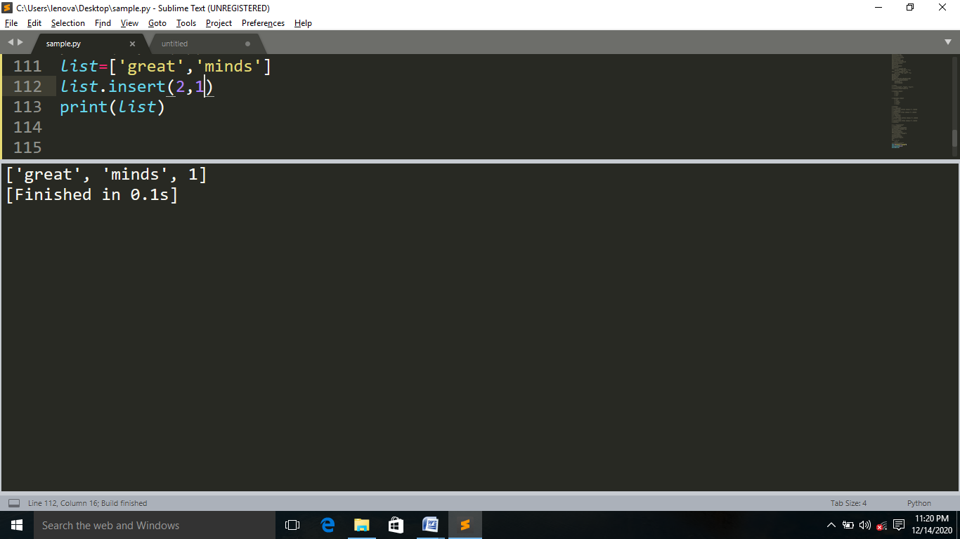

**POP:**It removes and returns last value from the list or the given index value.The value at index is popped out and removed. If the index is not given,then the last element is popped out and removed. It has backup.

**Syntax**: list.pop()

**EXAMPLE:**

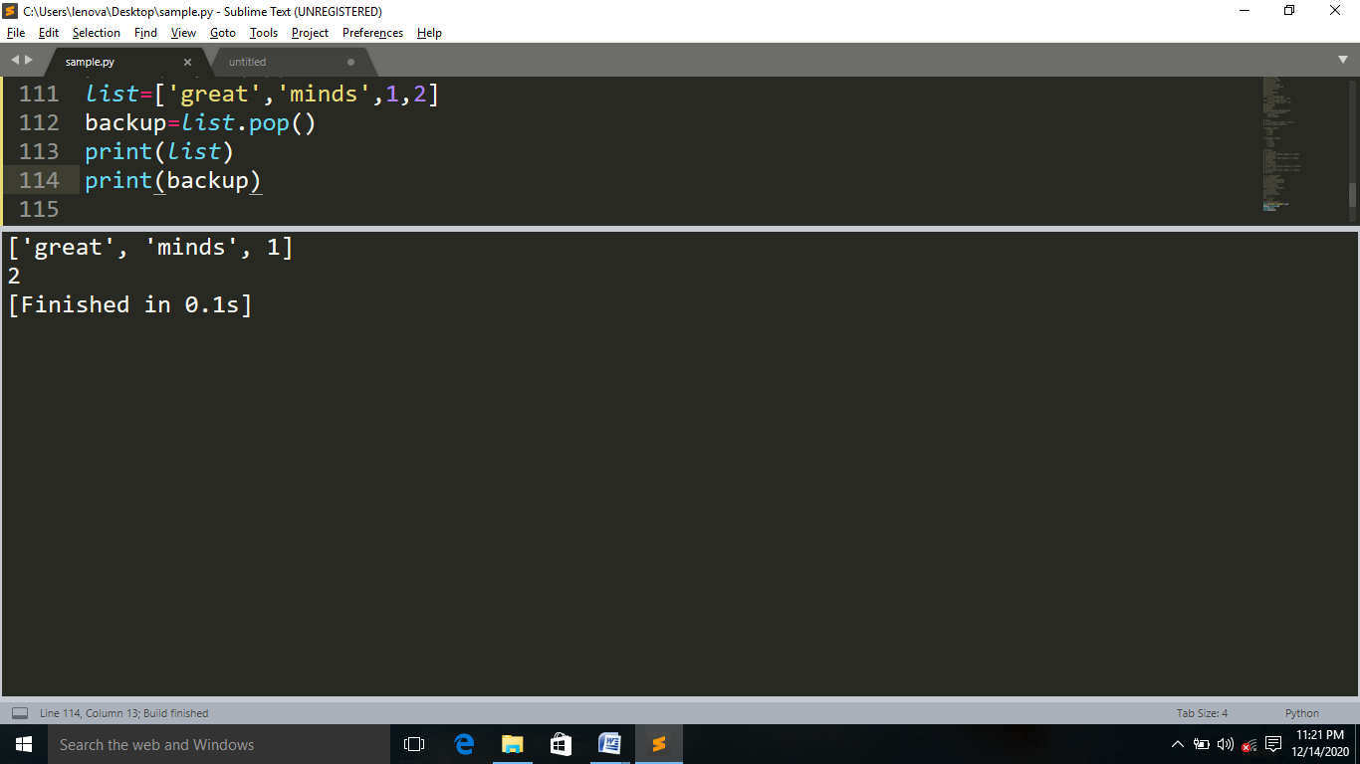

**REMOVE:** The remove() method removes the first occurrences of the element with the specified value,that removes the given object from the list,doesnot return any value,it has no backup.

**Syntax:**

list.remove()🡺exactly takes one arguments

**EXAMPLE:**

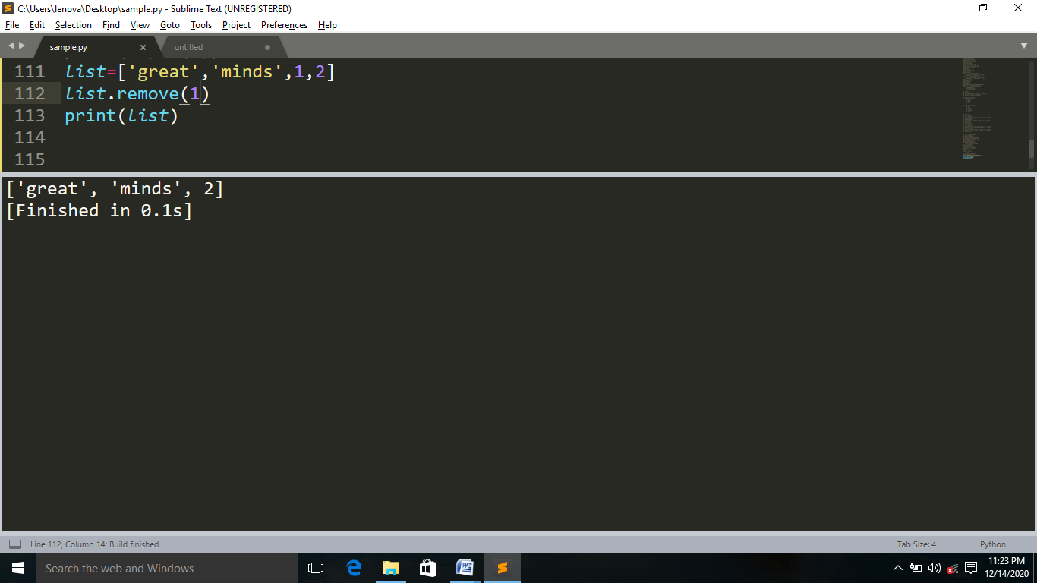

**REVERSE:**The reverse() method reverse the current sorting order of the elements.

**Syntax:**

list.reverse()

**EXAMPLE:**

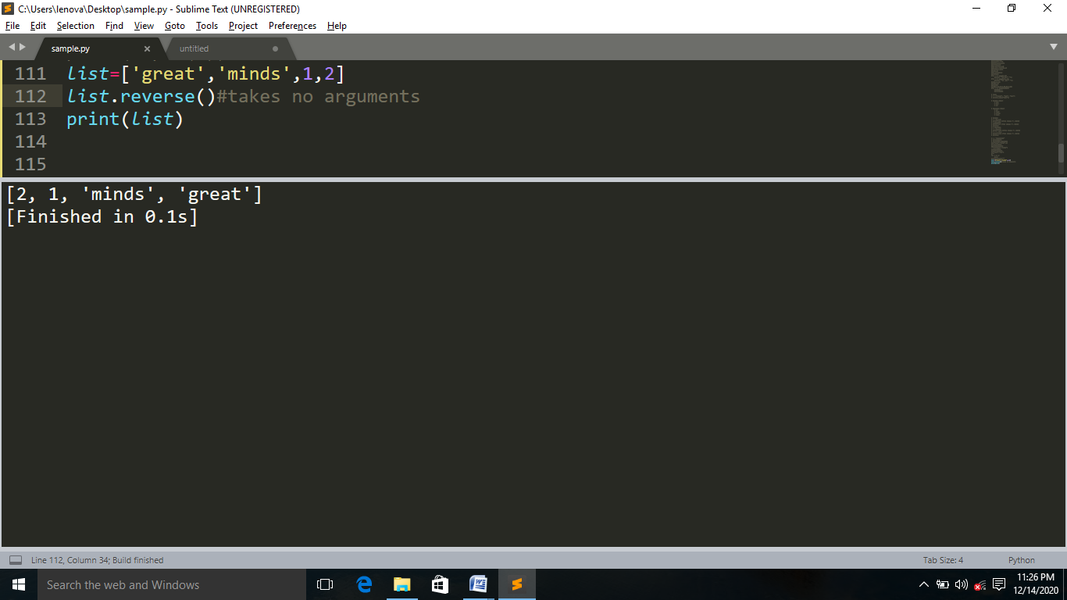

**COUNT:**It returns the number of elements with the specific value.

**Syntax:**

List.count(value)

**EXAMPLE:**

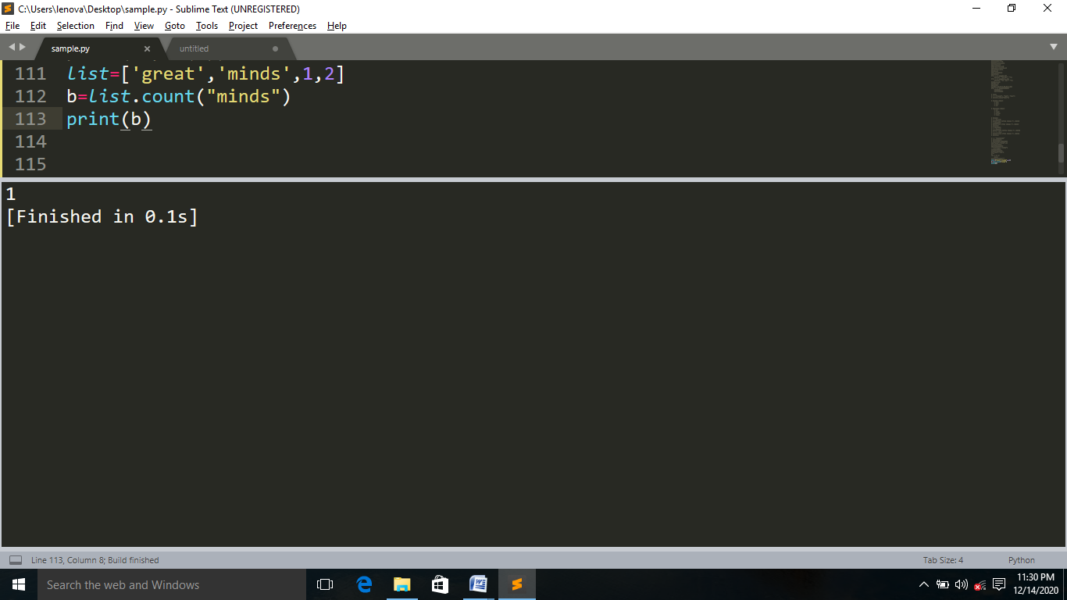

**SORT:**The sort() method sort the elements of a given list in a specific ascending or descending order.

**Syntax:**

list.sort()🡺for ascending order.

list.sort(reverse=True)🡺for descending order.

**EXAMPLE:**

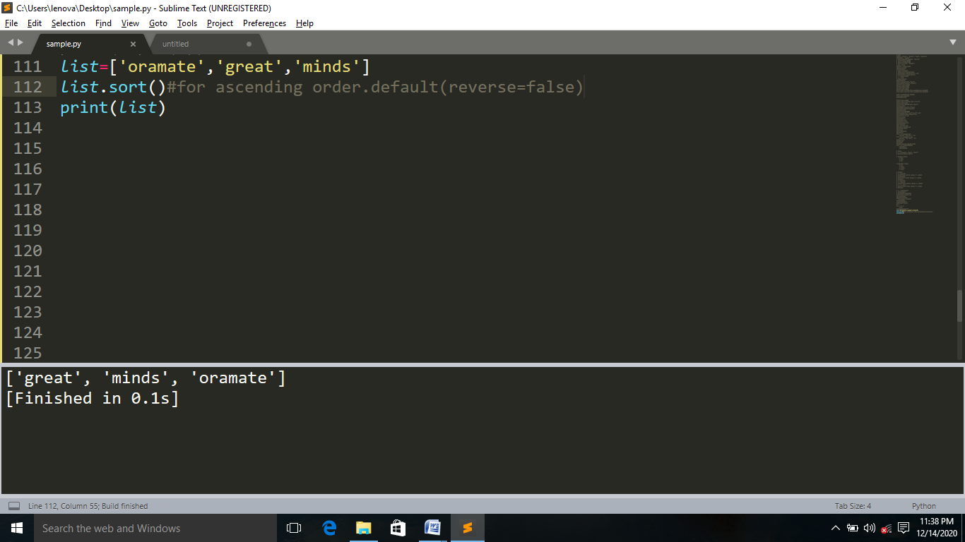

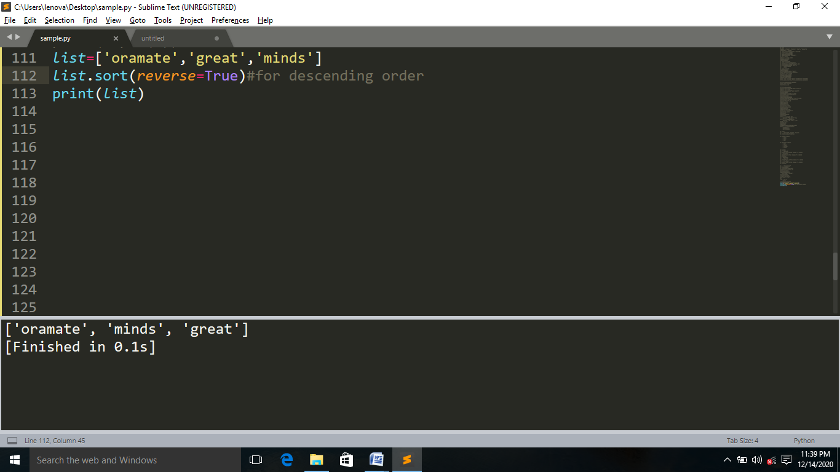

**COPY:**Cannot copy a list simply by typing list2=list1,because list2 will only be a reference to list1,and changes made in list1 will automatically also be made in list2.To avoid this use built-in list method copy()

**Syntax:**

list2=list1.copy()

**EXAMPLE:**

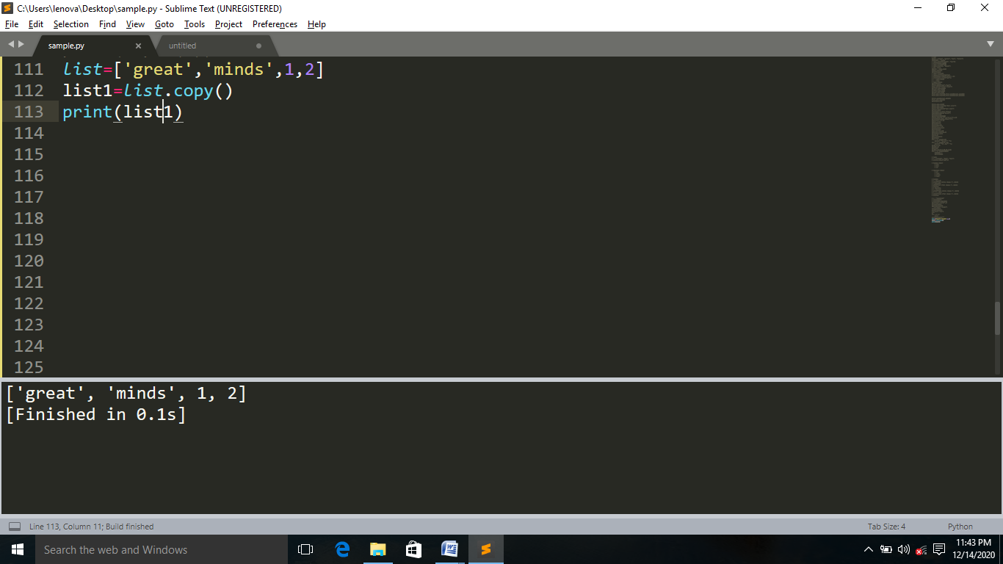

**CLEAR:** The clear () method empties the list,the list still remains ,but it has no content.

**Syntax:**

list.clear()

**EXAMPLE:**

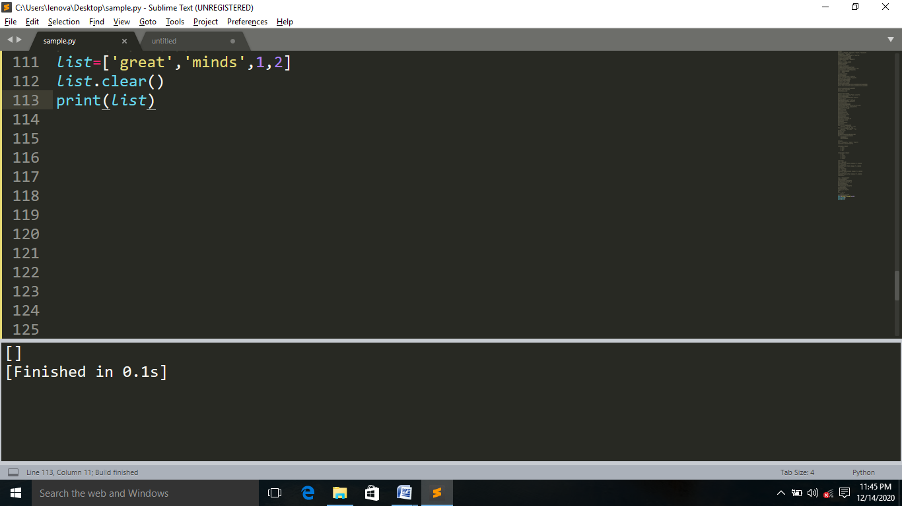

**TASK:**

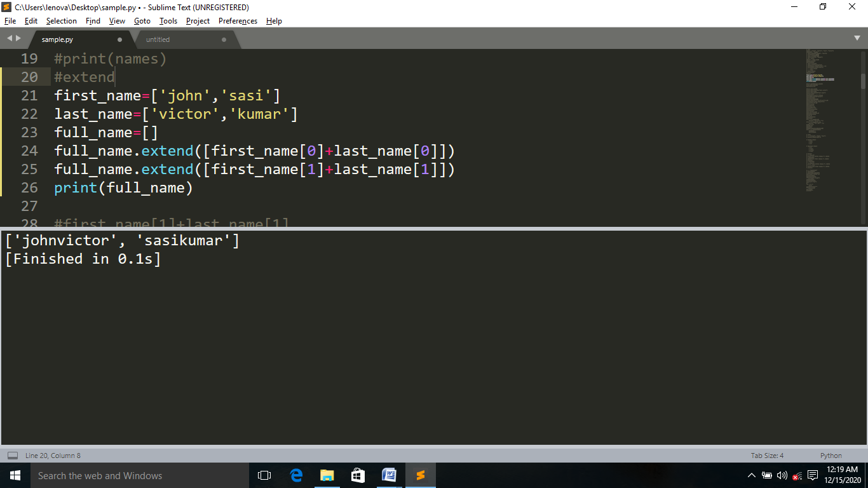

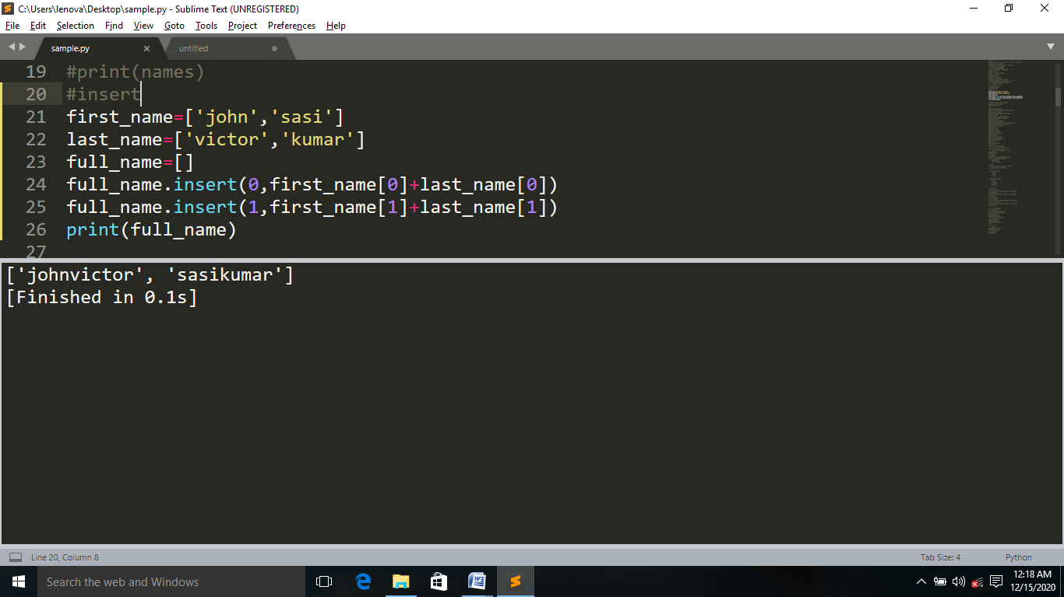

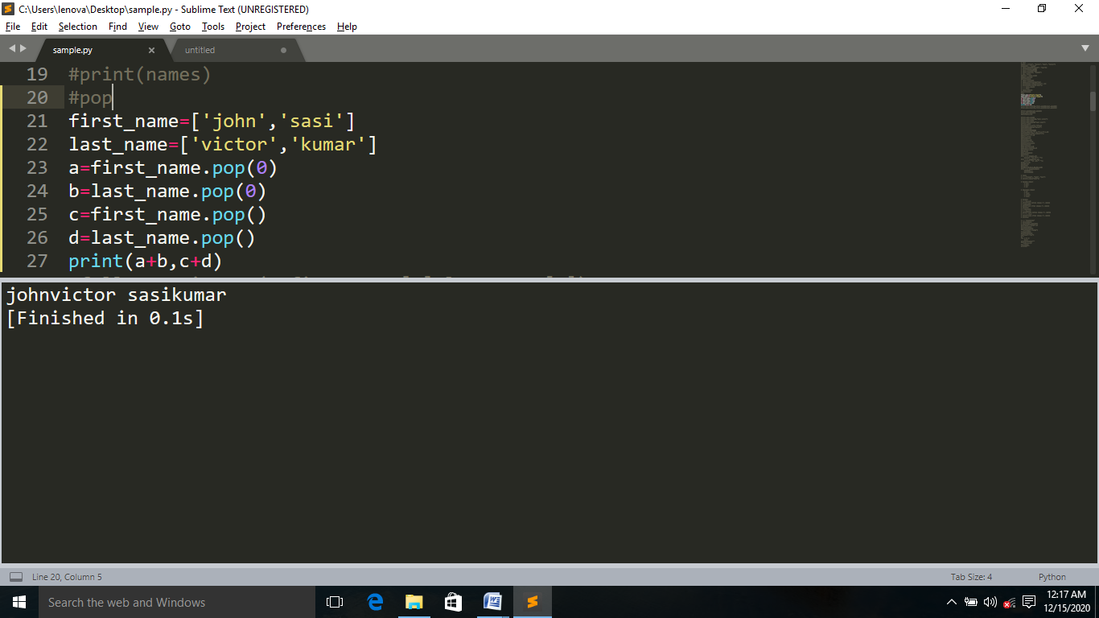

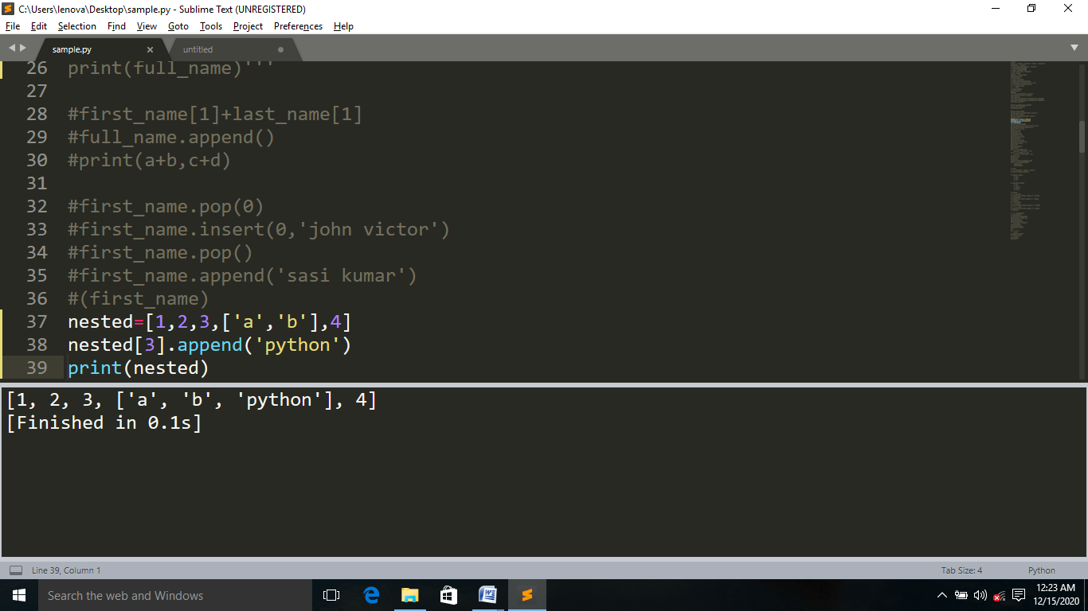

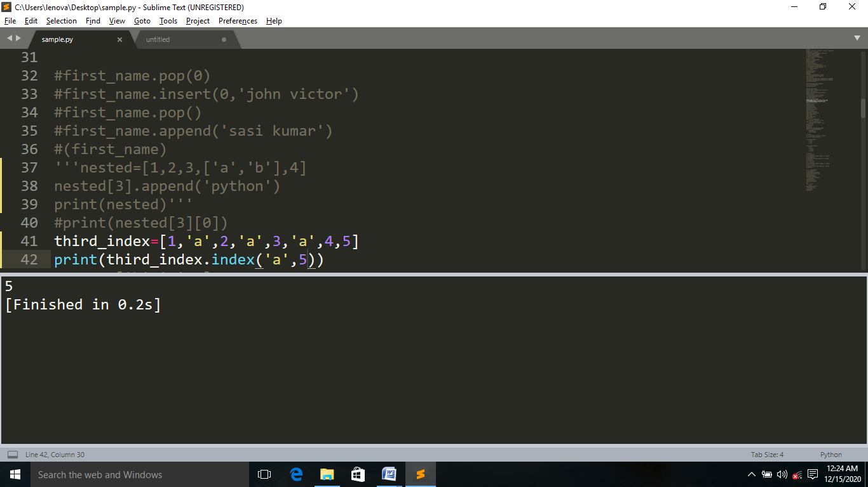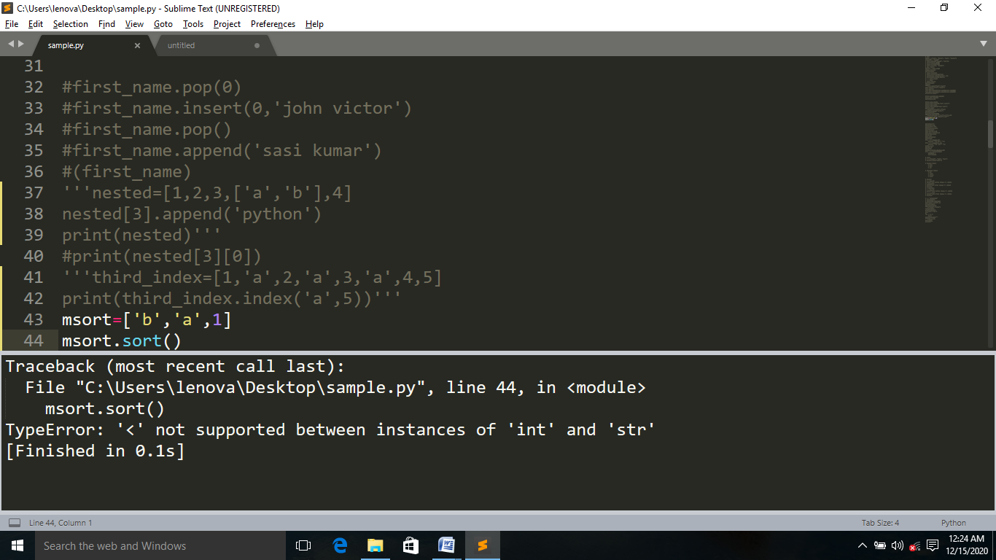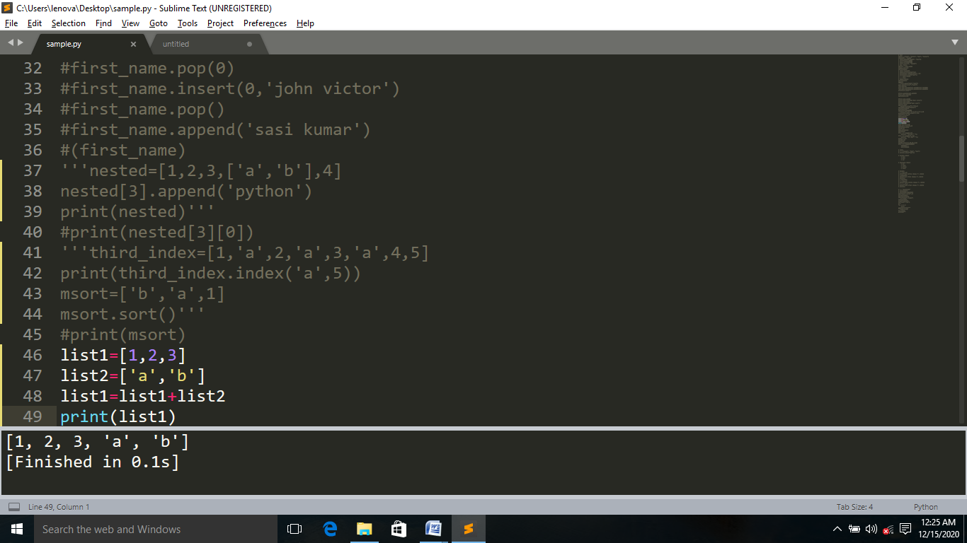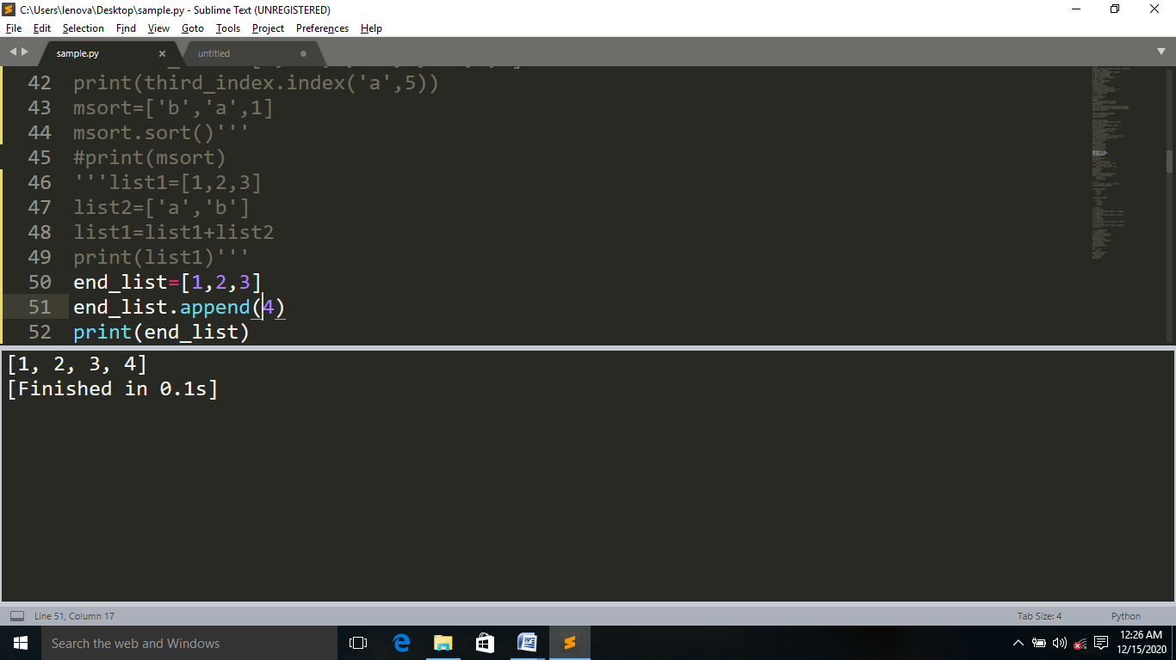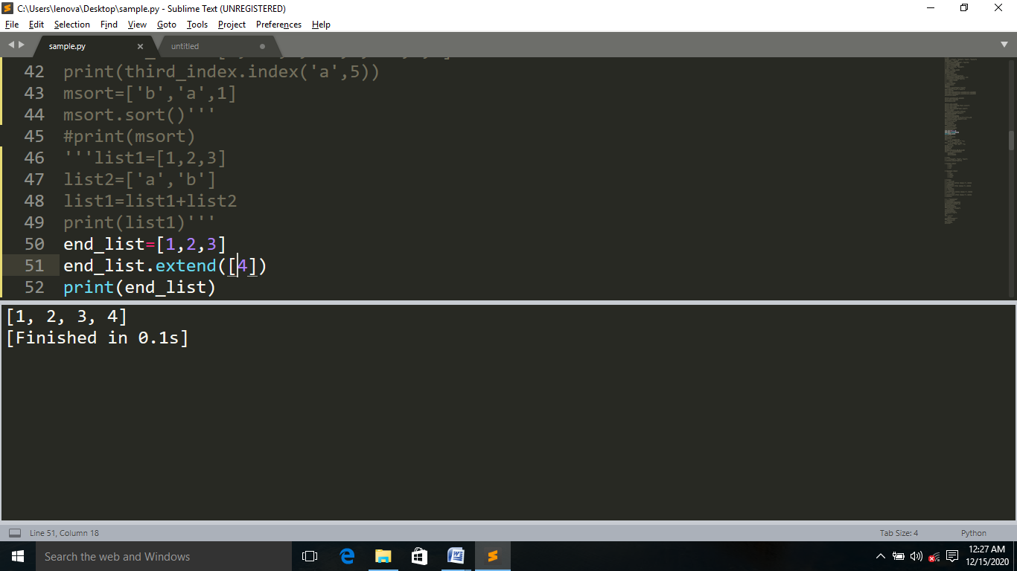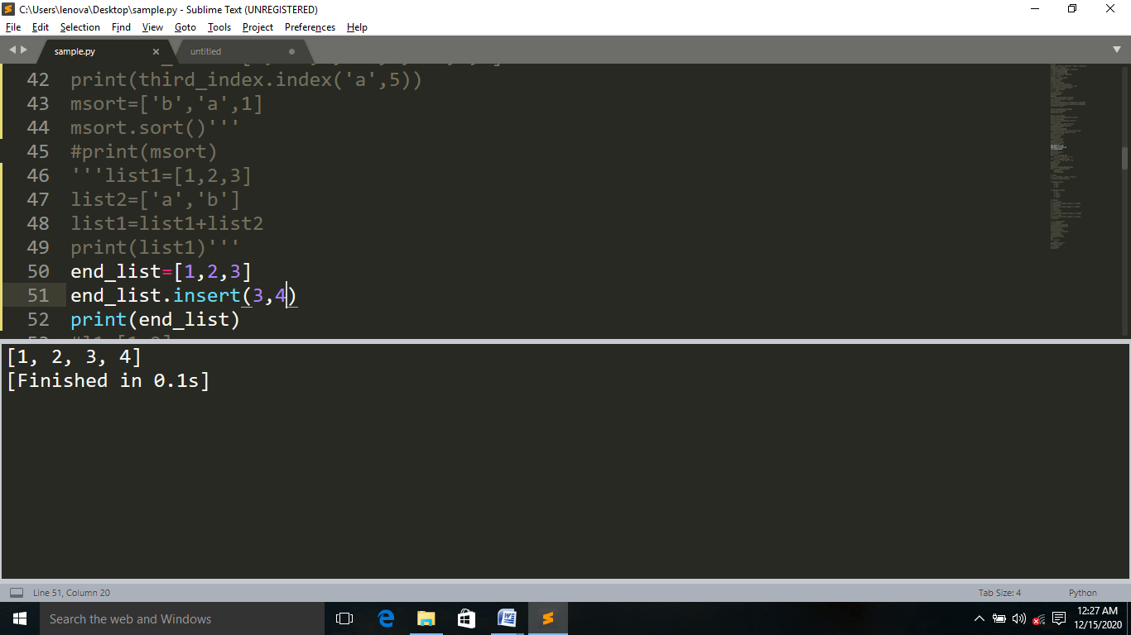**Pattern programs  
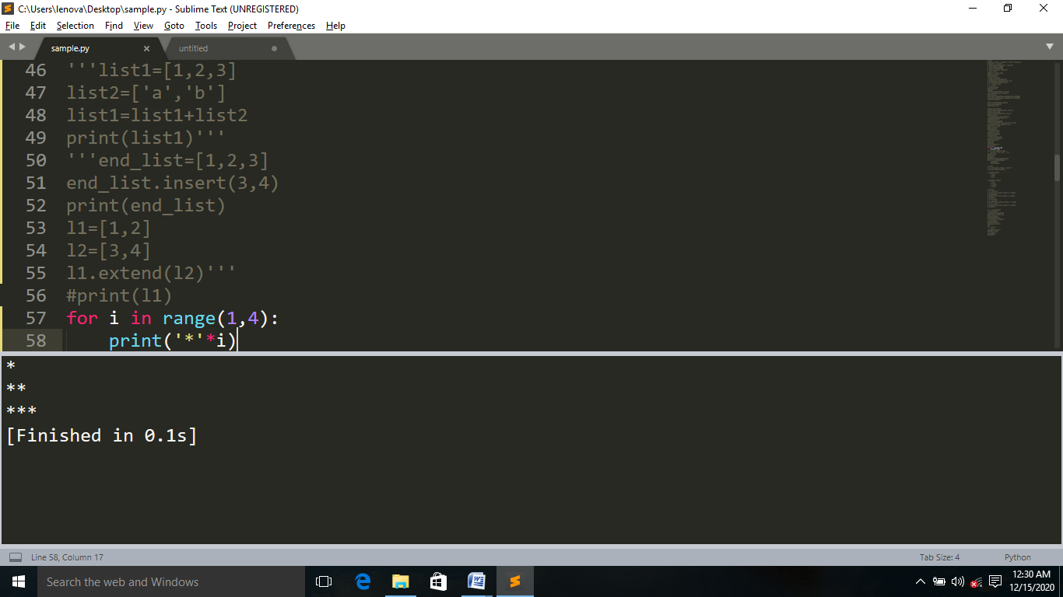  
  
  
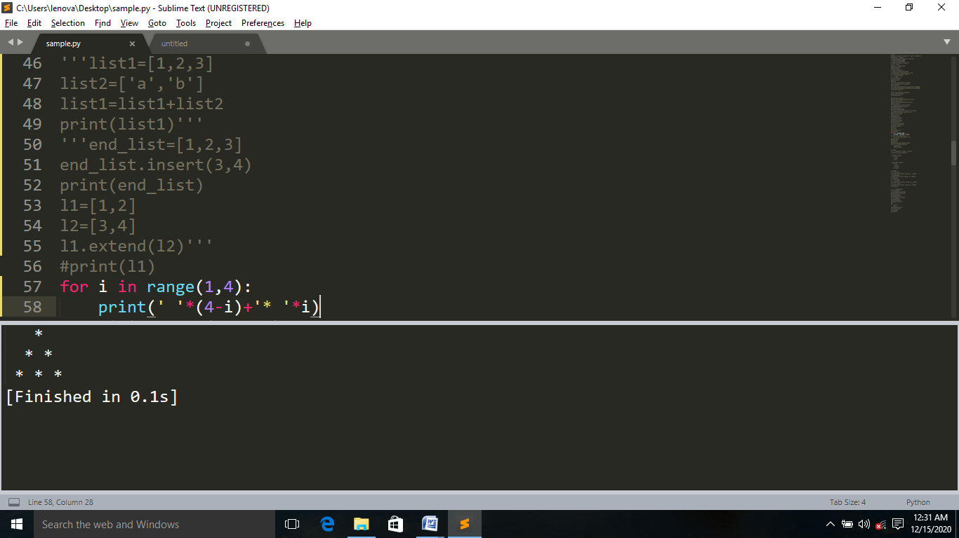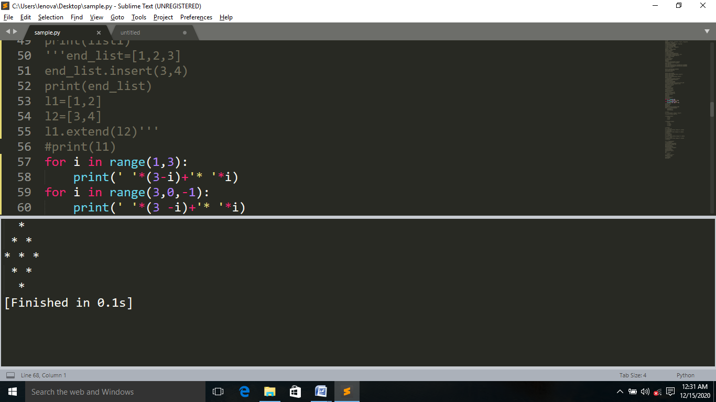**

**Daigonal value as one  
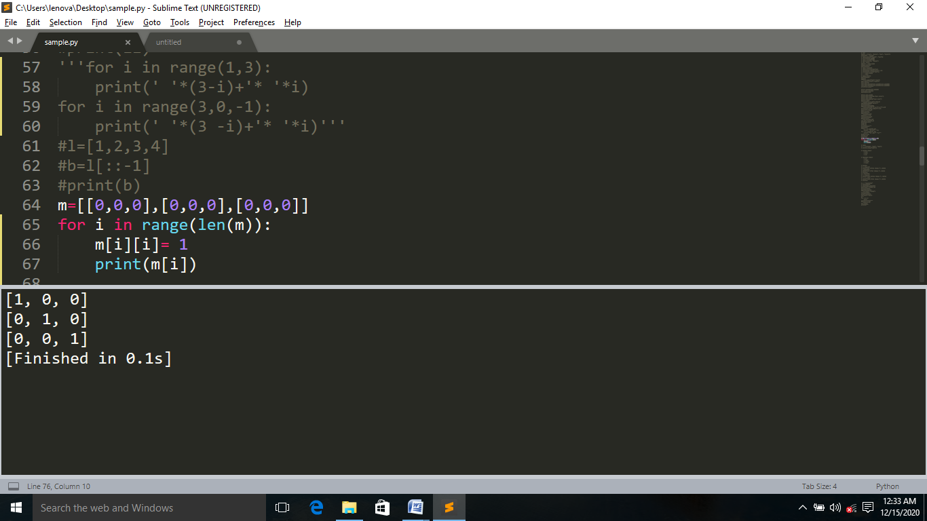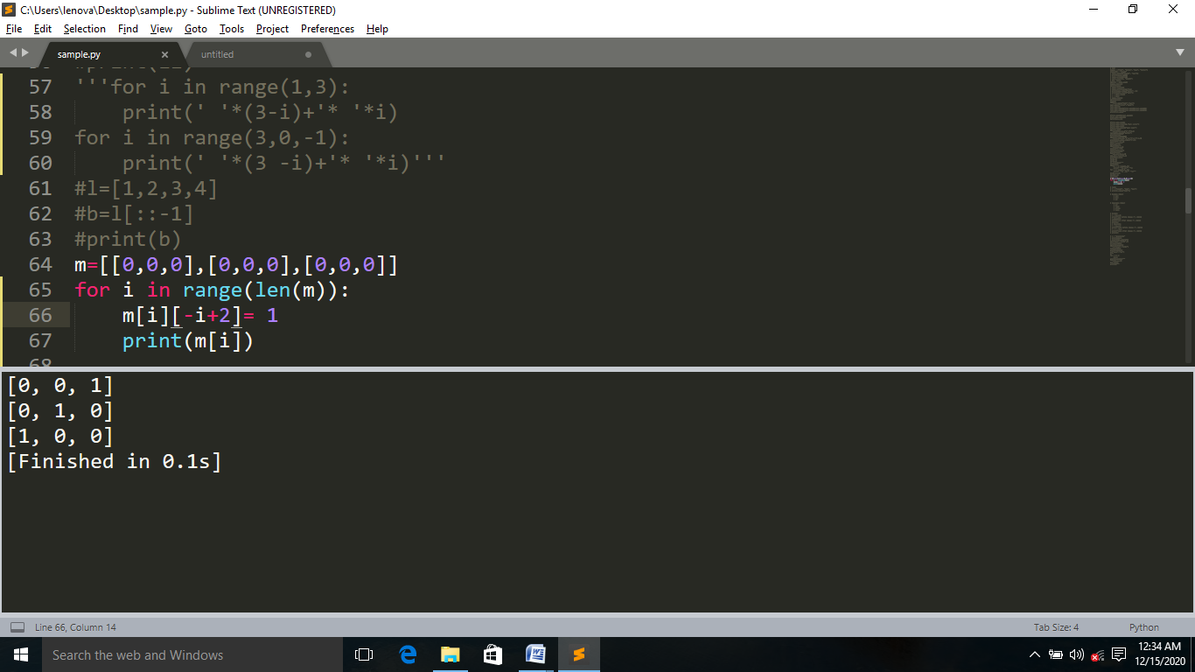**

**Print the numbers in Reverse order**